**TEMASEK POLYTECHNIC**

**SCHOOL OF INFORMATICS & IT**

**DIPLOMA IN IMMERSIVE MEDIA & GAME DEVELOPMENT**

**AY2025/2026 APRIL SEMESTER (LEVEL 2)**

**GADV (CGE2C25)**

**Introduction to Unity (Part 2)**

**Basic Scripting**

To see the additional comments and resources, make sure you select **All Markup** in the **Review/Tracking** pane



**Objectives**

In this worksheet, you’ll learn how scripts work in Unity and how they affect objects in your scene. Unity uses a system where you add components to objects to give them different functions. Instead of building everything using complicated code structures, you can simply attach scripts and other components to GameObjects to make them do what you want.

You will start by learning how to create and run scripts, then move on to accessing components and modifying GameObjects.

Finally, you will write simple scripts to change an object’s color and make it rotate, introducing important Unity concepts such as GetComponent<>(), serialized fields, and the Inspector. By the end of this worksheet, you will have a better understanding of how scripts drive gameplay in Unity.

Have fun! 😊

1. **How Scripts Run in Unity**

First, we need to look at how scripts are executed in Unity. This is different from the programming you did in Year 1.

**1.1 What is a Component-Based Architecture?**

**1.1.1 GameObject and Components**

Unity follows a **component-based** architecture, meaning that objects in a scene are built using **GameObjects** and **Components**. This is different from traditional **Object-Oriented Programming (OOP)**, where behaviour is often defined through class hierarchies (superclasses and subclasses).

In Unity, a **GameObject** is a container, and its behaviour is defined by the components attached to it.

This approach provides flexibility because you can **add, remove, and modify components dynamically** without needing complex class hierarchies.

* + 1. **Components are just Scripts**

A component is just a script!

In Unity, scripts do not run on their own—they must be attached to **GameObjects** in the scene. Unlike some programming environments where a script executes from a main() function, Unity's execution model relies on GameObjects and Components.

In Unity, all functionality in the game comes from Components attached to GameObjects. A script in Unity is just another **Component**, specifically a **MonoBehaviour Component**, which must be assigned to a GameObject for it to execute. We’ll look at the MonoBehaviour component later.

But before we create and run a script, we need to do some setting up.

**1.2 Setting up**

**1.2.1 Managing your files**

First, create a new folder for this worksheet, as show below. Add the **Scenes** and **Scripts** folders, as usual.

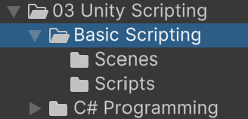

Create a new scene, and save it in the Scenes folder as **BasicScripting**.

Then right-click inside the Scripts folder, and create a new MonoBehaviour script.

While the new script is highlighted, click on the name and change it to **GameManager**.

A new script called **GameManager.cs** will be created. You don’t need to add the .cs when renaming the script.



It’s important to structure your project folders well so that you (and your team-mates if working as a group) can navigate and find files easily.

**1.2.2 Set your IDE (Integrated Development Environment)**

You should have done this already, but if not do it now.

Make sure that Visual Studio is set as your external editor. Go to the **Edit/Preferences** menu option and set the External Script Editor to Visual Studio:

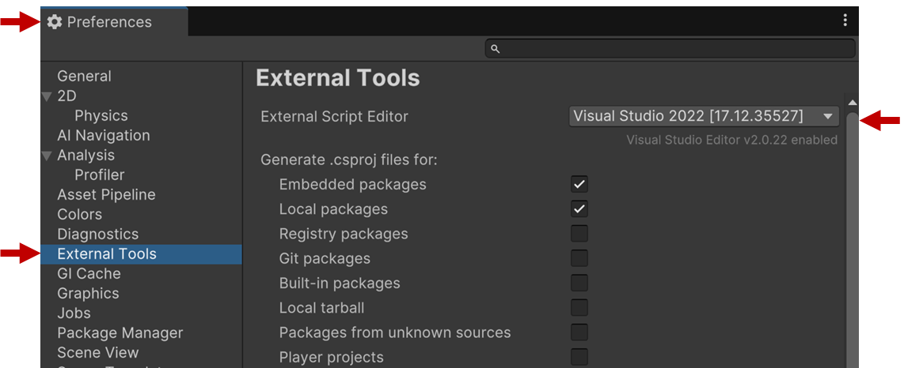

**1.3 Creating and running the Script**

1. Add this code to your script (double-click on the script in Unity and wait for Visual Studio to open):

using UnityEngine;

public class GameManager : MonoBehaviour

{

void Start()

{

    Debug.Log("This script is attached to a GameObject!");

}

}

Run the project.

Nothing happens!

This is because the script isn’t attached to a GameObject in the scene. To actually run the script, you have to create a GameObject, then attach your script as a **component**.

1. Right-click in the Hierarchy and create a new empty GameObject called **Manager**. You’ve learned how to do this in a previous worksheet.
2. Attach the GameManager script to the Manager GameObject.
3. Select the Manager GameObject in the Hierarchy.
4. Drag the GameManager script fron the Scripts folder onto the blank area in the Inspector as shown below.
5. Note that GameManager is added as a component to the GameObject.

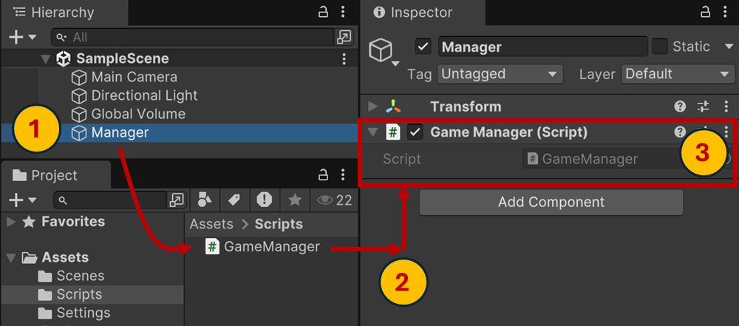

1. Run the project.

You should now see the message printed in the Console window:

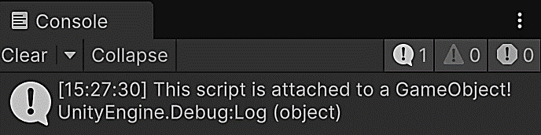

This script doesn’t do anything useful. To be useful, a script should affect the game in some way.

For example, scripts might:

* Load resources needed by a game
* Respond to user input
* Manage object interactions via physics (moving, colliding, etc)
* Play audio
* Access game data, e.g. a player’s stats
* … and much more!

We’ll create some simple scripts here, and then in future worksheets look at more complex scripting.

1. **Some Simple Example Scripts**

**2.1 Understanding Scripts and GameObjects**

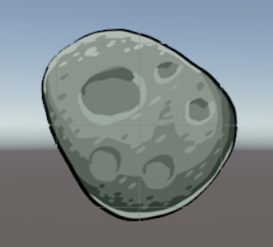

In the **previous worksheet**, you created an **Asteroid** GameObject. Now, let’s explore how scripts interact with their ***own* GameObject** and other scripts attached to it.

Every GameObject in Unity is made up of **components**. Some common components include:

* **Transform** – Controls position, rotation, and scale.
* **SpriteRenderer** – Defines how a sprite looks (its image and color).
* **Collider** – Detects collisions.

Here. we see the Asteroid object’s **Transform** and **SpriteRenderer** components:

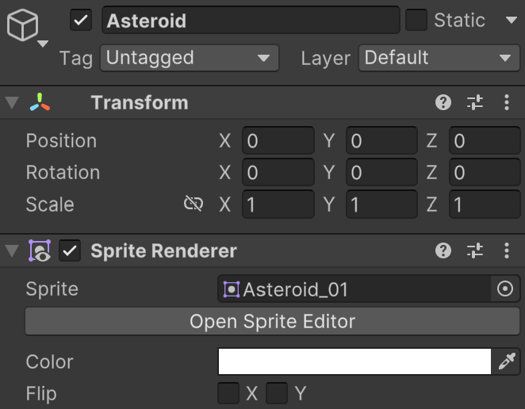

Remember: a component is just a script.

When attached to a GameObject, it can:

* Access and modify components on the same GameObject (e.g., change its position, scale, or color by modifying the Transform or SpriteRenderer component).
* Interact with other scripts attached to the same GameObject (e.g., call functions or change variables in another script to coordinate behaviors).

Let’s see this in action.

**Example 1: Accessing a Component to Change the Asteroid’s Color**

Before we changing GameObject’s color, we need to access the GameObject’s **SpriteRenderer** component.

**Step 1: Open Your Asteroid GameObject**

* Use the **Asteroid GameObject** you created in the previous worksheet.
* It already has a **SpriteRenderer** component.

**Step 2: Create a New Script**

* In the **Scripts** folder, create a **C# script** and name it **AsteroidColourTinter**.
* Attach it to the **Asteroid** GameObject in the Inspector.

**Step 3: Modify the Script**

Open Asteroid.cs and replace its contents with:

using UnityEngine;

public class AsteroidColourTinter : MonoBehaviour

{

    void Update()

    {

        if (Input.GetKeyDown(KeyCode.Space))

        {

            // Access the SpriteRenderer component

            SpriteRenderer spriteRenderer = GetComponent<SpriteRenderer>();

            // Change the color to blue

            spriteRenderer.color = Color.blue;

        }

    }

}

Run the project.

The asteroid sprite should become blue tinted when you press the space bar:

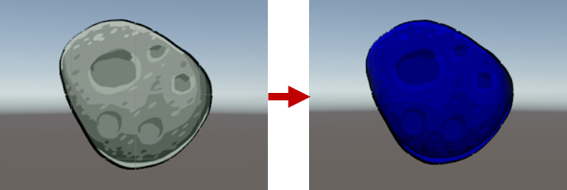

**How This Works:**

1. **GetComponent<SpriteRenderer>()** retrieves the SpriteRenderer component.
2. **spriteRenderer.color = Color.blue;** changes the color to blue when the player presses spacebar.

**Exercise 1: Make the Asteroid Toggle Between Colors**

Modify AsteroidColourTinter.cs so that:

* pressing the spacebar toggles the asteroid’s color between its normal tint and blue.



Hint: Use an if statement to check the current color before changing it. Also note that the default colour for a SpriteRender is white, which displays the sprite normally without any tinting.



Let your tutor know that you’ve completed Exercise 1.

If you aren’t sure what to do, try to explain why here, e.g. you still don’t understand what the equation about does. Then put up your hand and ask your tutor for guidance.

**Example 2: Making the Asteroid Rotate Continuously**

We’ve seen how scripts can access components and interact with each other. Now let’s create another simple script to make the **Asteroid rotate**.

This will introduce an important Unity concept: **Serialized Fields**, which allow us to **adjust values in the Inspector** without modifying the script.

**Understanding Serialized Fields and the Inspector**

In Unity, public variables in a script appear in the **Inspector**, where they can be adjusted without changing code.

This is called serialization, since the variable’s value is stored by Unity so that it can be used when the project runs and the script executes.

**Implementation**

We will create a script that continuously **rotates the asteroid**, with a **rotation speed** adjustable in the Inspector.

* In the **Scripts** folder, create a new **C# script** and name it **AsteroidRotator**.
* Attach it to the **Asteroid GameObject**.

Open AsteroidRotator.cs and replace its contents with:

using UnityEngine;

public class AsteroidRotator : MonoBehaviour

{

    public float rotationSpeed = 30f; // Default rotation speed

    void Update()

    {

        // Rotate the asteroid continuously

        transform.Rotate(0, 0, rotationSpeed * Time.deltaTime);

    }

}

When you run the project, the asteroid should rotate at a constant speed:



**How it works:**

1. **Public float rotationSpeed = 30f;**

* Because rotationSpeed is set to be public, it appears in the **Inspector**, where we can change it without editing any code.
* The default value we’ve set is **30 degrees per second**.

1. **transform.Rotate****(0, 0, rotationSpeed * Time.deltaTime);**

* Rotates the GameObject around the **Z-axis** (to spin like a top).

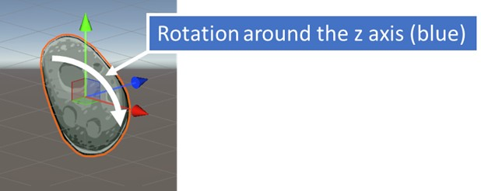

Io the code above, the X axis is red, the Y axis is green, and the Z axis is blue: **(0, 0, rotationSpeed * Time.deltaTime)**.

So, the GameObject is rotated around its Z axis by **rotationSpeed * Time.deltaTime** degrees every frame.

* **Time.deltaTime** ensures smooth rotation, **independent of frame rate**.

**Adjusting the Rotation Speed in the Inspector**

* Select the Asteroid GameObject.
* Look at the Inspector.
* In the AsteroidRotator component, find the Rotation Speed field.
* Try changing the value to 10 or 100, then press Play.

A **higher value** makes spins it faster, and a **lower value** slows it down.

**Exercise 2a: Change the rotation speed**

Modify AsteroidRotator.cs so that the asteroid rotates at a different speed.

**Hint:** Try setting rotationSpeed to 100 in the Inspector and see what happens.

**Exercise 2b: Make the rotation direction adjustable**

Modify AsteroidRotator.cs so that a **positive** rotation speed rotates **clockwise** and a **negative** rotation speed rotates **counterclockwise**.

**Hint:** Try setting rotationSpeed = -30 in the Inspector and see what happens.



Let your tutor know that you’ve completed Exercise 2 a and 2b.

If you aren’t sure what to do, try to explain why here, e.g. you still don’t understand what the equation about does. Then put up your hand and ask your tutor for guidance.

**Summary**

This worksheet introduced several key concepts about scripting in Unity:

* **Component-Based Architecture**: Unity’s system where GameObjects gain functionality by attaching components, including scripts.
* **Scripts as Components**: Scripts do not run independently—they must be attached to GameObjects.
* **Accessing Components with GetComponent<>()**: Scripts can retrieve and modify other components on the same GameObject (e.g., SpriteRenderer to change color).
* **Interacting with Other Scripts**: Scripts attached to the same GameObject can communicate and modify each other’s behavior.
* **Serialized Fields (public variables)**: Allow variables to be displayed and edited in the **Inspector**.
* **Using the Inspector**: Public variables appear in the Inspector, where values can be adjusted without changing code.

**IMPORTANT**

Note that we created two scripts for the asteroid:

* AsteroidColourTinter
* AsteroidRotator

In Unity, it is best practice to **split functionality into smaller, focused scripts** rather than writing a single large script that handles everything.

This follows the **Single Responsibility Principle (SRP)**, making each script responsible for only one aspect of the GameObject’s behavior.

But what is the Single Responsibility Principle?

Let’s ask Chat GPT:

**What is the Single Responsibility Principle in programming?**

It responds with:

The Single Responsibility Principle is one of the core principles of clean code and software design. It states that a class (or script) should have only one reason to change, meaning it should be responsible for just one well-defined task.

How This Applies to Unity:

In Unity, scripts act as components that define a GameObject’s behavior. If a script tries to handle multiple responsibilities, such as movement, animations, and player input all in one, it becomes difficult to read, debug, and maintain.

Instead, it is better to split functionality into smaller, focused scripts. For example:

* A PlayerMovement script handles movement.
* A PlayerHealth script manages health and damage.
* A PlayerAnimation script controls animations.

Each script has only one job, making it easier to update, reuse, and troubleshoot. By following SRP, your Unity projects become more organized, scalable, and maintainable.

This is a pretty good response.

In fact, our class names are still rather too specific. The code will work for any sprite. So we should really rename them to **AsteroidColourTinter** and **SpriteRotator**. These can then be added to any sprite GameObject!

We’ll cover this in more detail in future, as well as other topics about software design for games.

Congratulations for making it this far! 😊

Now explore the suggested resources on the next page.

**Suggested Resources**

You should look for your own tutorials and resources, but here are a few good links for you to explore.

* [Unity Learn: Scripting Playlist](https://www.youtube.com/watch?v=PCdg3cnQfZ4): An excellent playlist of official Unity Learn videos about scrioting. It’s for an older version of Unity, but is still very relevant.
* [Unity Manual: Components](https://docs.unity3d.com/Manual/unity-components.html):

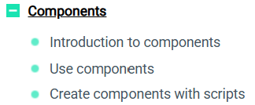

* [Unity Manual: Scripting](https://docs.unity3d.com/Manual/scripting.html):

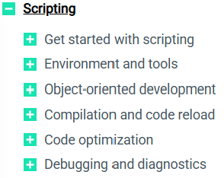

* [Unity Official Tutorial – Components](https://www.youtube.com/watch?v=Z0Z7xc18CcA): A short tutorial about components from Unity’s official YouTube channel.
* [Unity Official Tutorial – GetComponent in Unity](https://www.youtube.com/watch?v=xbDKC4zP9XY): A short tutorial about the GetComponent() method from Unity’s official YouTube channel.
* Coursera: Complete C# for Unity Game Development Specialization: An excellent online course from Coursera! You must sign up.
* [Linked-In Learning—Learning Unity 2D Scripting](https://www.linkedin.com/learning/learning-unity-2d-scripting/what-you-should-know?autoSkip=true&resume=false&u=76881922): An excellent, more beginner-friendly, Linked-In course all about scripting in Unity. As a TP student, you have a free membership of Linked-In Learning. Click on the link, or search for the course title in Unity. You’ll be asked to sign on using your TP credentials.
* [Linked-In Learning—Unity Certified Associate Game Developer Scripting with C# Scripting with C# in Unity](https://www.linkedin.com/learning/cert-prep-unity-certified-associate-game-developer-scripting-with-c-sharp/scripting-with-c-sharp-in-unity): An excellent, and very comprehensive (i.e. long) course about scripting in Unity. This is designed for those taking the Unity Certification exam, but it’s worth exploring.

